

SCHOOL OF COMPUTING

UUM COLLEGE OF ARTS AND SCIENCES

STIA1123 PROGRAMMING 2

A202 GROUP I

Exercise 1

MADE FOR

Prof. Madya Dr. Azman Yasin

MADE BY

|  |  |
| --- | --- |
| NAME | MATRIC NUMBER |
| VANISRI MANIKAM | 278328 |

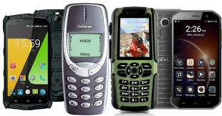

|  |
| --- |
| behavior/methods   * Calling( ) * Receive message( ) * Send message( ) * Play songs( ) * Connect Bluetooth( ) |

|  |
| --- |
| Properties |
| * Colour * Size * Storage * Model |

Mobile phones

|  |
| --- |
| behavior/Methods |
| * Walk( ) * Eat( ) * Speak( ) * Sleep( ) * Dance( ) |

|  |
| --- |
| Properties |
| * Name * Gender * Age * Weight * Height |

Human



|  |
| --- |
| behavior/Methods |
| * Switch on/ off ( ) * Volume control ( ) * Tuner/change channel( ) * Display movies ( ) |

|  |
| --- |
| Properties |
| * Height * Width * Buttons * Remote control |

Televisyen

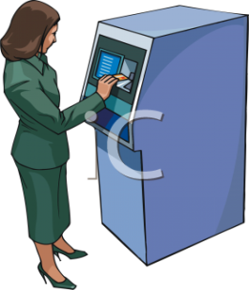

|  |
| --- |
| Properties |
| * Name * Account number * Pin number |

Bank

|  |
| --- |
| behavior/Methods |
| * Amount withdraw( ) * Deposit( ) * Check balance ( ) |



|  |
| --- |
| Properties |
| * Wings * Tail * Feathers * Claws |

|  |
| --- |
| behavior/Methods |
| * Fly ( ) * Eat ( ) |

Birds